FINAL REPORT

TCD Practicum LAS 6941

Participatory Arts and Science for Youth Engagement in Biocultural Diversity Conservation in the Colombian Amazon

CAROLINA SIMON-PARDO

School of Environment and Natural Resources
Interdisciplinary Ecology PhD Program
Tropical Conservation and Development Certificate Program

PhD advisor: Dr. Yue Li
School of Forest, Fisheries, and Geomatics Sciences (SFFGS)
UF Institute of Food and Agricultural Sciences (UF/IFAS)

Summer 2025

Introduction
Problem Statement
Science and environmental education in Indigenous territories continue to be limited by two interconnected problems: the historical disconnect between academic research and Indigenous communities, and the persistent exclusion of Indigenous knowledge, values, and territories from school curricula. Research in Indigenous lands has long operated within extractive paradigms that treat communities as data sources rather than co-researchers or decision-makers (Smith, 2012; Smith et al., 2023; Haelewaters et al., 2021), leaving little space for Indigenous participation in defining questions, interpreting results, or guiding how knowledge circulates (Louis, 2007; Simpson, 2014). Even when collaborations are described as participatory, outputs such as biodiversity surveys or TEK documentation often remain disconnected from community priorities and unused in local decision-making or education (Tengö et al., 2017; McCarter et al., 2014). As a result, these materials seldom reach classrooms, weakening the link between knowledge production, Indigenous self-determination, and youth learning (Aikenhead & Michell, 2011; Bang & Medin, 2010). At the same time, science curricula in many Amazonian schools are adapted from Western frameworks that marginalize Indigenous epistemologies (Wirth, C, 2020; Latip et al., 2024), contributing to cultural devaluation and undermining belonging, intergenerational learning, and the development of culturally grounded scientific competencies (Battiste, 2013; Freire, 1970; Cajete, 2020). Despite policy frameworks affirming the importance of Indigenous knowledge, meaningful articulation between community knowledge, formal education, and research remains limited (Nemogá et al., 2022; Ochoa & Gómez, 2018). This gap underscores the need for approaches that authentically integrate Indigenous knowledge systems into science education and strengthen biocultural conservation.
Significance
Indigenous territories in the Amazon are globally significant because their ecological integrity is sustained through complex knowledge systems that link ecological understanding with cultural values, governance, and long-term stewardship (Varese et al., 2021; Abas et al., 2022). These territories cover more than a quarter of the Amazon biome and are essential for biodiversity conservation, climate regulation, and ecosystem resilience (Science Panel for the Amazon, 2021). For Indigenous peoples, however, these lands are not only ecologically important but also central to identity, well-being, and future self-determination. Scientific frameworks such as the Intergovernmental Science-Policy Platform on Biodiversity and Ecosystem Services (IPBES), emphasize that Indigenous and local knowledge is indispensable for understanding human–nature relationships and guiding sustainable conservation strategies (IPBES, 2019; Athayde et al., 2021). Research shows that when Indigenous knowledge systems and formal education meaningfully complement one another, youth are better prepared to steward their territories and support sustainable development (Hill et al., 2020). Yet few educational models authentically weave Indigenous ecological knowledge, local languages, and culturally grounded science pedagogy. By examining participatory, place-based approaches to science education, this practicum and my ongoing study address a critical gap and contributes to both educational transformation and biocultural conservation.
Collaborating community
In the past 2 years of conducting my research I have collaborated with AZICATCH, the Indigenous Zonal Association of Traditional Councils and Authorities of La Chorrera, which unites the Uitoto, Bora, Okaina, and Muinane peoples in the Predio Putumayo territory, one of the largest Indigenous reserves in the Colombian Amazon. These communities speak four languages with eight variants, calling themselves “Sons of Tobacco, Coca, and Sweet Yucca,” sacred plants central to their material and spiritual sustenance. Established in 2004, AZICATCH, their Indigenous association, has worked to recover traditions and languages lost during the rubber boom era, which devastated their ancestors.
The location of the practicum was the school “Casa del Conocimiento” (School House of Knowledge), created in 1994 to support education rooted in their cultural values. The school is composed of an elementary branch for the grades K-5 and an upper grade branch for the grades 6-11, both located in the urban center of La Chorrera. These two branches serve 600 students in total. Six additional smaller elementary schools serve 150 students in total, from remote communities along the river. Students in these schools, grades K-5, study all together with a single teacher in one or two classrooms in a system widely used in Colombia for rural education called multigrade.
(Azicatch Facebook website)

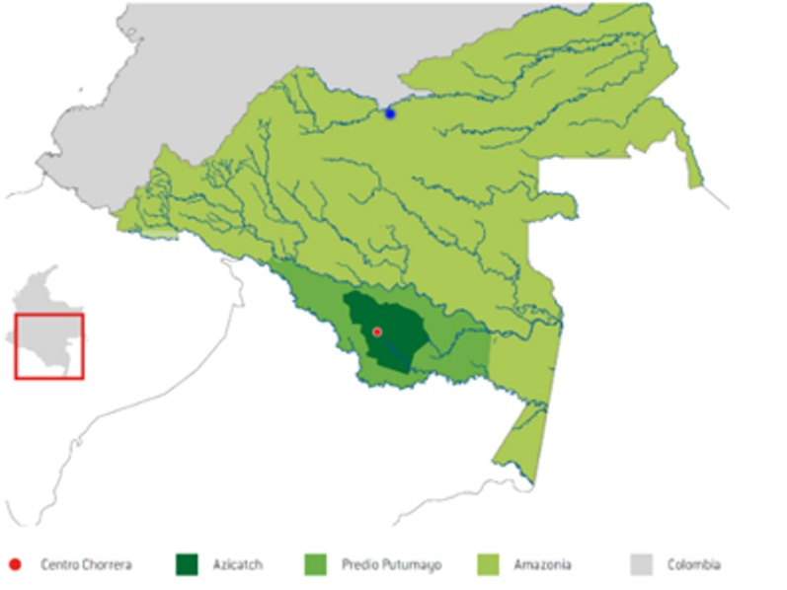 | The AZICATCH Indigenous territory, located along the mid-course of the Igará-Paraná River in the Colombian Amazon, spans approximately 1,620,000 hectares, representing 28% of a broader reservation area covering 5,850,000 hectares (AZICATCH, 2022). It forms part of the Resguardo Predio Putumayo, one of the largest multiethnic Indigenous reserves in the country. Indigenous territories collectively cover about 31% of Colombia’s total land area, with the Colombian Amazon accounting for 42% of the nation’s territory. Around 50% of the Colombian Amazon is both Indigenous territory and protected natural area, highlighting the crucial role Indigenous governance plays in conservation.
Map 1. Map of the AZICATCH Indigenous territory in the Colombian Amazon. The territory spans approximately 1,620,000 hectares along the Igará-Paraná River and forms part of the Resguardo Predio Putumayo. Data from AZICATCH Environmental Plan Management (2022) and WWF Colombia (2023). Blue dot represents San Jose del Guaviare, and Red dot is La Chorrera.

Knowledge Exchange with Yauda Foundation and Amazonian Research Networks
With the aim of supporting the teacher’s interest in learning how to integrate learning activities for indigenous languages and Artificial Intelligence strategies in education, I invited Nicolas, a linguistics student, member of the Yauda Foundation student collective at the Universidad Nacional de Colombia.
The Colombian Foundation Yauda, is an NGO founded by young researchers dedicated to support Indigenous youth in the Amazon. These researchers work in the linguistics and anthropology fields in different parts of the Colombian Amazon. As part of the preparation for the Practicum, Nicolas and I met with other members of Yauda to learn about their experiences. Our travel to La Chorrera in the Amazon from Bogotá, the capital city in Colombia, required the stop in the city San José del Guaviare, located at the North of the Amazon in Colombia. This place is considered the door to the Amazon as it is connected by road to the Andes allowing commerce and cultural exchange. The Yauda members living in this city work with youth from the nomad groups who face forced displacement and health, mental and social risk conditions for surviving in urban centers such as San Jose.
This encounter created an important space for knowledge exchange, where each participant shared experiences working with Indigenous peoples and the evolving social challenges affecting Indigenous youth. Their extensive expertise, particularly in understanding youth aspirations, intergenerational dynamics, and ongoing social transformations, greatly enriched our preparation for fieldwork. They also provided practical tools for engaging respectfully with traditional knowledge and for supporting teachers as collaborators and co-researchers in the project.
His participation focused on sharing with teachers and the community in La Chorrera, about his experience conducting linguistic and cultural revitalization projects with youth and teachers alongside Uitoto communities near Leguízamo, a settlement in the Western Amazon. He shared his strategies to engage youth in finding new ways for cultural expression using digital media and re-thinking education. Through his stay in La Chorrera, he shared with the local community about his experience learning the Uitoto language variants in that region.
(Yauda Foundation website)
Practicum Activities: Workshops with Teachers, Youth, Elders, and Community Researchers

Activity 1. AI-Supported Lesson Design Workshop (Teachers, Elementary and Secondary)

This workshop introduced teachers to the critical use of Artificial Intelligence (AI) for lesson planning and curriculum development. Ten teachers from elementary and upper grades participated. Due to heavy rains midyear, a flood severely impacted the Highschool building in La Chorrera (May-July 2025). The Highschool students and teachers where sharing the elementary building, elementary functioned in the morning and high school in the afternoon.

The workshop was held during midday, when teacher schedules converged. The session began with activities exploring teachers’ personal learning histories and the concept of nature as a teacher through drawing and collective reflection. Teachers then practiced developing AI prompts aligned with desired learning outcomes, used a mental map for designing prompts while analyzing risks, limitations, and ethical considerations of AI in education.

Learning outcomes:
– Ability to design prompts for lesson planning aligned with educational goals
– Critical understanding of AI’s risks and limitations in Indigenous education
– Reflection on personal identity, educational pathways, and relationship with nature

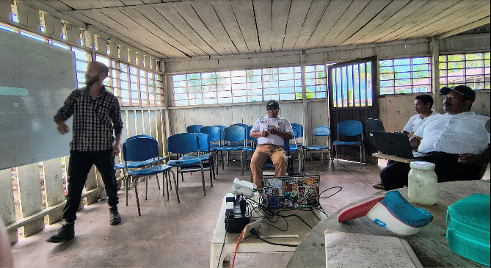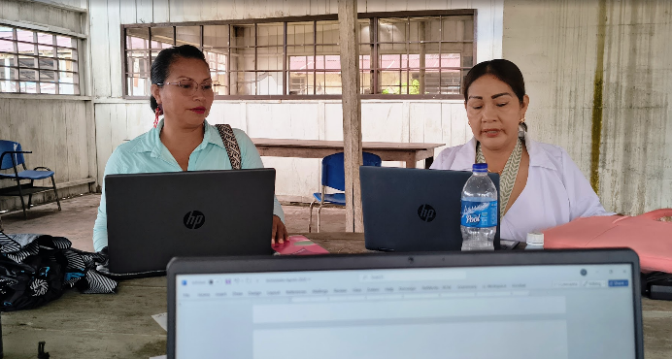

Activity 2. Nature Observation Walks with Binoculars (9th Grade and Science Teacher)
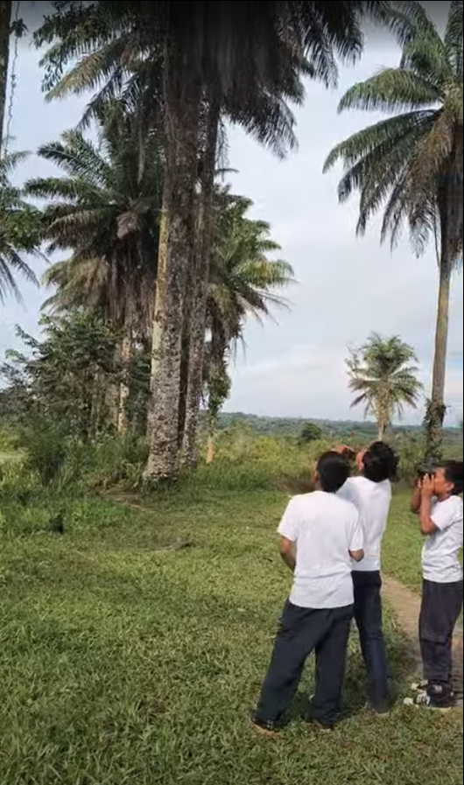
Teachers and students conducted guided nature observations using binoculars to examine changes in the environment after rainfall. Participants practiced taking field notes, asking questions, and connecting observations to traditional ecological knowledge. Two walks: one in the elementary area and one in the upper school, allowed the group to identify natural elements that could serve as future investigation topics. Classroom activities followed, in which students practiced formulating questions and reflecting on their observations.
Learning outcomes:
– Teachers practiced guiding binocular-based explorations connected to weather and ecological patterns
– Students improved questioning skills and observation techniques
– Identification of biophysical features for future school-based investigations

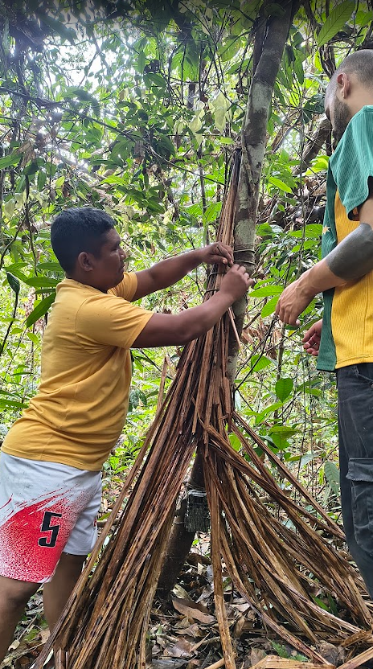
Activity 3. Camera Trap Biodiversity Exploration (3rd Grade)
A 3rd-grade teacher and her students learned how to install, program, and manage a camera trap for documenting biodiversity in the surrounding floodplain forest. The group explored fruiting trees and the animals interacting with them, later reviewing the captured images and videos in class. Students practiced question sequences to support collective reflection and deepen their understanding of animal behavior. Activities also included learning games using local Indigenous languages for names of animals and fruits, reinforcing community knowledge and peer learning.
Learning outcomes:
– Teacher ability to set up, manage, and integrate camera trap data into classroom activities
– Student development of questioning skills based on digital biodiversity images
– Strengthening of local language use related to forest species
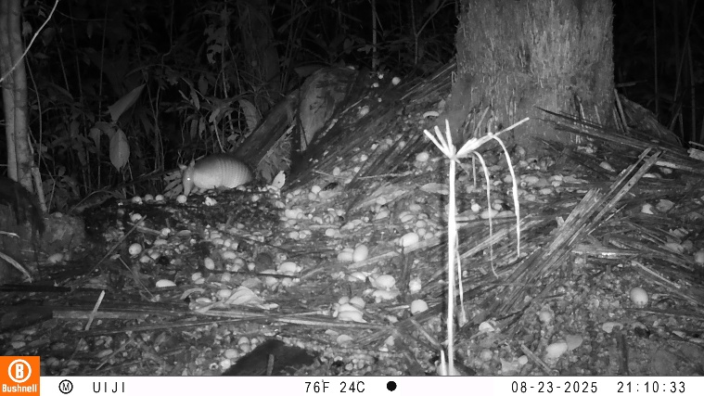 | 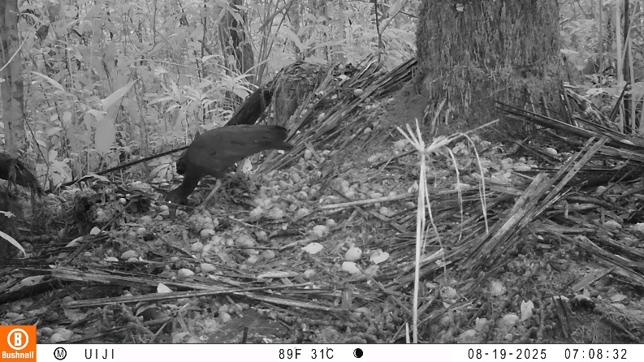
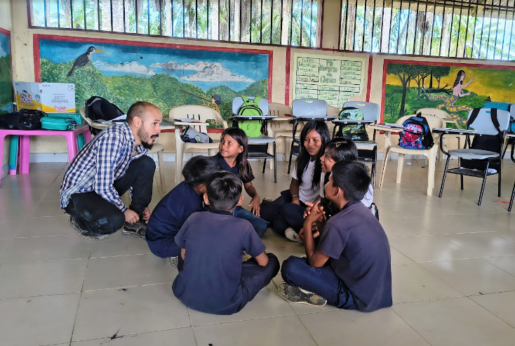 | 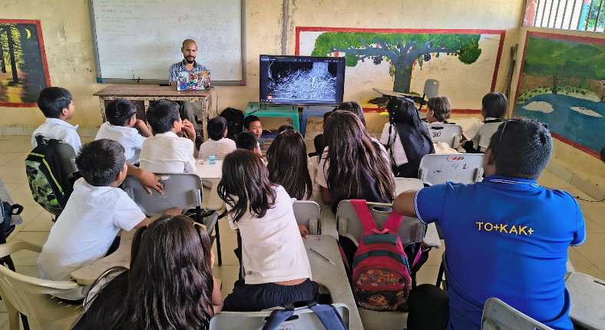

Activity 4. Elder–Youth Language Revitalization Circle Using Student Drawings
This community-based workshop explored innovative ways to teach Indigenous languages by inviting elders and youth into a shared circle traditionally reserved for adults. The researcher brought student made hand-drawn images of local biodiversity and used them to ask elders about names, meanings, and associated cultural stories. Elders from two different language groups participated, allowing for comparison of linguistic forms and cultural interpretations.
Learning outcomes:
– Use of student artwork as a tool for language teaching and intercultural dialogue
– Strengthening of intergenerational learning spaces
– Exposure to linguistic diversity and comparisons across Indigenous languages
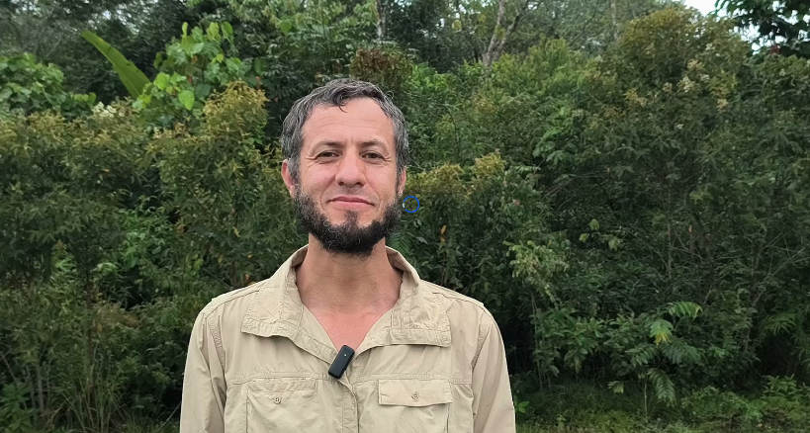
Activity 5. Filming Educational Media with Visiting Researchers
During a visit from a botanist from Sinchi Institute, teachers and students participated in the filming of short educational videos explaining the origins of the floodplain forest and discussing scientific and Indigenous explanations of ecological processes. The session emphasized the integration of the scientific method with Indigenous knowledge systems as complementary ways of knowing.
Learning outcomes:
– Early development of ideas for creating locally grounded educational materials
– Introduction to “Two-Eyed Seeing” approaches, combining scientific and Indigenous perspectives
– Strengthening teacher capacity to contextualize science concepts within local ecological knowledge

Activity 6. Student Biodiversity Drawing Showcase (Grades 3–11)
A school-wide exhibition was organized to display biodiversity drawings created by students in grades 3–5 and 6–11. The showcase was set up in a multipurpose space typically used for teacher lunches and meetings. Because upper-grade students were temporarily sharing the elementary school facilities due to recent flooding, the exhibition was accessible to students from all grade levels throughout the day. The drawings—produced as part of the research on using media to support learning about biodiversity—were displayed to invite interpretation and dialogue. Teachers, students, and school staff interacted with the artwork, sharing their perceptions with the researcher and with one another.
Learning outcomes:
– Students saw how their artwork contributed to collective research and learning process
– Teachers reflected on student perspectives and artistic representations of biodiversity
– Community members engaged with the exhibition, strengthening visibility and appreciation of youth contributions
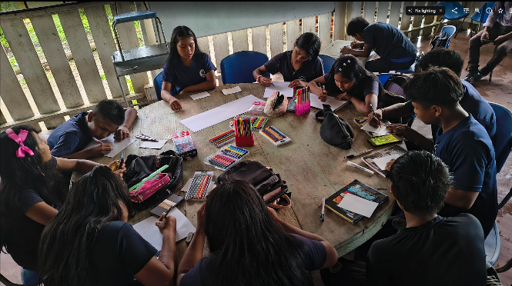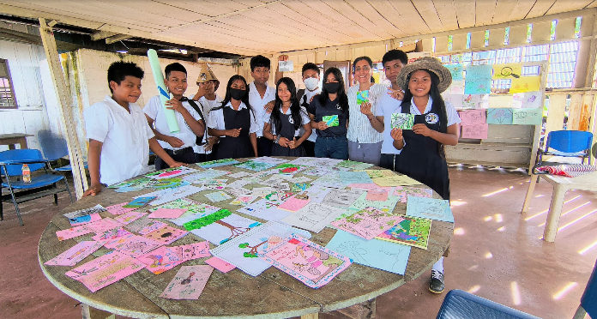

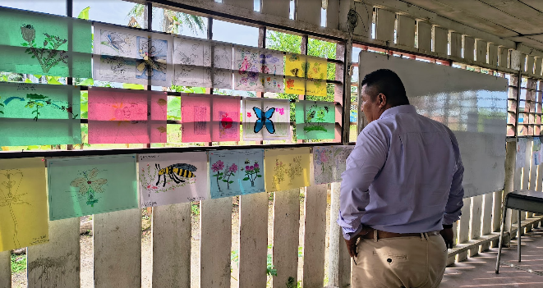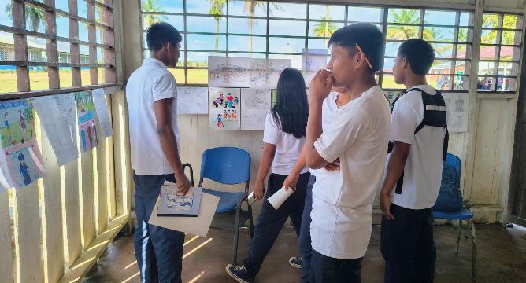

Final Remarks and Future Steps
The practicum activities demonstrated the growing commitment of teachers, students, and community members to co-design a culturally grounded science and environmental education that reflects the ecological and cultural realities of the territory. Through workshops centered on observing the flood forest, documenting biodiversity with camera traps, exploring insect behavior, and connecting weather patterns with fruiting cycles and pollination, teachers began to integrate local ecological processes into meaningful classroom practices. Drawing, binocular-based observation, and multimodal media approaches helped students and teachers experiment with new ways of noticing and interpreting the environment, while also creating entry points for discussing Traditional Ecological Knowledge (TEK) in school-based learning.
These activities marked an important shift toward teachers’ growing confidence as co-designers of their own curriculum. Their engagement in lesson planning, field-based inquiry, language revitalization practices, and AI-supported pedagogical design indicates the emergence of a collaborative culture that values both scientific and Indigenous ways of knowing. The participation of elders, youth, and regional researchers further enriched this process, strengthening the links between school learning, community knowledge, and territorial stewardship.
Looking ahead, this research will continue deepen this collaborative work by supporting teachers in exploring the flood forest, medicinal gardens, schoolyard ecosystems, and other culturally meaningful spaces as learning sites. Future steps include co-developing learning modules focused on insect observation, pollination processes, fruiting cycles of key trees, and biocultural indicators that reflect the community’s understanding of environmental change. Mapping the school and surrounding ecosystems will allow teachers and students to visualize the places they study, identify seasonal patterns, and formulate research questions connected to TEK.
Youth will be further empowered as co-researchers by participating in ongoing biodiversity monitoring, documenting weather–ecosystem relationships, and contributing drawings, videos, photos, and sound recordings to collective inquiry cycles. Likewise, teachers will continue strengthening their role as curriculum designers, integrating participatory science, Indigenous knowledge, and place-based pedagogies into structured units that can be sustained over time.
Together, these future steps advance the broader goal of creating a school program that bridges formal science education with the community’s ecological and cultural knowledge systems, cultivating the next generation of Indigenous researchers, caretakers, and decision-makers for the territory.

References
Abas, A., Aziz, A., & Awang, A. (2022). A systematic review on the local wisdom of Indigenous people in nature conservation. Sustainability, 14(6), Article 3415. https://doi.org/10.3390/su14063415
Aikenhead, G., & Michell, H. (2011). Bridging cultures: Scientific and Indigenous ways of knowing nature. Pearson Canada.
Athayde, S., Silva-Lugo, J., Schmink, M., & Heckenberger, M. (2017). The same, but different: Indigenous knowledge retention, erosion, and innovation in the Brazilian Amazon. https://doi.org/10.1007/s10745-017-9930-0
Bang, M., & Medin, D. (2010). Cultural processes in science education: Supporting the navigation of multiple epistemologies. Science Education, 94(6), 1008–1026. https://doi.org/10.1002/sce.20392
Battiste, M. (2013). Decolonizing education: Nourishing the learning spirit. Purich Publishing.
Cajete, G. (2000). Native science: Natural laws of interdependence. Clear Light Publishers.
Haelewaters, D., Hofmann, T. A., & Romero-Olivares, A. L. (2021). Ten simple rules for Global North researchers to stop perpetuating helicopter research in the Global South. PLOS Computational Biology, 17(8), e1009277. https://doi.org/10.1371/journal.pcbi.1009277
Hill, R., Nates-Parra, G., et al. (2020). Biocultural approaches to pollinator conservation. Nature Sustainability, 2, 214–222. https://doi.org/10.1038/s41893-019-0244-z
IPBES. (2019). Global assessment report on biodiversity and ecosystem services. Intergovernmental Science-Policy Platform on Biodiversity and Ecosystem Services.
Latip, A., Hernani, & Kadarohman, A. (2024). Local and Indigenous knowledge (LIK) in science learning: A systematic literature review. Journal of Turkish Science Education, 21(4), 651–667.
Louis, R. P. (2007). Can you hear us now? Voices from the margin: Using Indigenous methodologies in geographic research. Geographical Research, 45(2), 130–139. https://doi.org/10.1111/j.1745-5871.2007.00443.x
McCarter, J., Gavin, M. C., Baereleo, S., & Love, M. C. (2014). The challenges of integrating Indigenous and scientific knowledge in climate change adaptation planning. Environmental Management, 52(3), 556–570.
Nemogá, G. R., Appasamy, A., & Romanow, C. A. (2022). Protecting Indigenous and local knowledge through a biocultural diversity framework. The Journal of Environment & Development, 31(3), 223–252. https://doi.org/10.1177/10704965221104781
Ochoa, G., & Gómez, A. (2018). Educación propia y políticas interculturales en Colombia. Revista Colombiana de Educación, 75, 55–75.
Science Panel for the Amazon. (2021). Amazon assessment report 2021. United Nations Sustainable Development Solutions Network.
Simpson, L. B. (2014). Land as pedagogy: Nishnaabeg intelligence and rebellious transformation. Decolonization: Indigeneity, Education & Society, 3(3), 1–25.
Smith, L. T. (2012). Decolonizing methodologies: Research and Indigenous peoples (2nd ed.). Zed Books.
Smith, L. T., Munshi, D., Munshi, D., Cruz, J., & Pal, M. (2023). Decolonizing knowledge: Cultural aspirations, political self-determination, and social rights in knowledge making. In Organizing at the margins (pp. 15–31).
Tengö, M., Hill, R., Malmer, P., Raymond, C. M., Spierenburg, M., Danielsen, F., Elmqvist, T., & Folke, C. (2017). Weaving knowledge systems in IPBES, CBD and beyond: Lessons learned for sustainability. Current Opinion in Environmental Sustainability, 26–27, 17–25. https://doi.org/10.1016/j.cosust.2016.12.005
Varese, M., Rodríguez, C., Piland, N., Athayde, S., Alvira Reyes, D., Rodrigues da Costa Doria, C., Echeverri, J. A., Jarrett, C., Matapi, U., Brito Maciel, N. J., Posada, V., Romualdo Román-Jitdutjaaño, O., Tello, L., & Trujillo, L. A. (2021). Chapter 33: Connecting and sharing diverse knowledges to support sustainable pathways in the Amazon. In Amazon Assessment Report 2021. UN Sustainable Development Solutions Network (SDSN). https://doi.org/10.55161/dyak8997
Wirth, C. (2022). Learning in the forest: An exploration of waorani education and its interaction with formal state schooling in the ecuadorian amazon (Order No. 31873735). Available from ProQuest Dissertations & Theses A&I; ProQuest Dissertations & Theses Global. (3172040679).

