|  |
| --- |
|  |

Report submitted for TCD practicum course during Spring 2024

By Shambadeb Basu

Graduate Student, Biology Department, University of Florida

**Practicum topic**: Capacity development and awareness building towards urban carnivores in a heavily urbanized landscape from Eastern India

Under supervision of Dr Catherine Tucker

Introduction:

Three species of small cats - Fishing Cat (*Prionailurus viverrinus*), Leopard Cat (*Prionailurus bengalensis*), and Jungle Cat (*Felis chaus*), the first of which is categorized as Endangered by the IUCN – currently occur within and around the Kolkata metropolitan area in Eastern India (Mukherjee at al. 2016). Considering this critical situation, Government of West Bengal, India declared the fishing cat as official “State Animal”. In West Bengal, these cats are distributed over a wide range of habitats, particularly in the Gangetic flood plains of East India and the mangrove vegetation of Sundarban Biosphere Reserve (SBR), which form most of the broad geographical range of southern West Bengal. Some of the major factors behind the human wildlife conflict (HWC) have been identified as habitat loss, urbanization, industrialization, conversion of natural land for agricultural extension, and commercial aquaculture faced by the predator outside the protected areas. As humans increasingly encroach on these cats' remaining habitat, for reasons including the expansion of commercial aquaculture into natural lakes and ponds, the human-cat conflict cases keep increasing in recent decades causing serious consequences for cat populations, especially the fishing cat. This area is among the most densely populated regions in the world and is the gateway to the SBR, which serves as a refuge for many elusive taxa, including carnivores adapted to live in this landscape. Despite having a long history of coexistence in a human dominated landscape, the extent to which these cats prey on livestock, as opposed to natural prey, is currently unknown. For getting an idea on that, one study being executed parallel to this practicum course objectives is looking at dietary spectrum of these cats from scat samples collected from the habitat which had known presence of fishing cat (FC)/ jungle cats (JC)/ leopard cats (LC) using genetic techniques.

The principal objective of this study was to understand the basis behind threat perceived by the locals from by these urban predators. Building on this objective were designing awareness towards the benefit of having these predators in the backyard, as discussed later. Socio-economic status and education affect people's attitudes concerning the native wildlife. The proposed study area has a gradient in terms of urbanization, from heavily urbanized in the metropolitan outskirts of Calcutta to the rural landscape around SBR. Past studies have found that the socio-economic structure around buffer areas of SBR comprise two groups of people: those who own large amounts of agricultural land and people who either do not own land or only have negligible land for themselves, including their homestead. Economic survival is challenging for the landless villagers, particularly those living at the boundary of the forest.

Study Area:

Looking through reports of HWC in the area for purpose of this practicum, I chose to focus on three counties surrounding the Kolkata metropolitan area. The study was carried out in East Midnapore, Howrah among the counties in the state of West Bengal along with the locations in south 24 Parganas district (Halliday Island, Lothian Island Wildlife Sanctuaries and Sajnakhali Wildlife Sanctuary) in the buffer areas of SBR (Fig 1), which are identified localities of fishing cat presence as reported by Das et al. 2017 and Chakraborty et al. 2020. As shown in Fig 1, the landscape worked on had evidence of both FC and JC presence and associated conflicts, found through the scat analysis study as well as previous camera trapping based evidence collection. The counties were selected based on their records of high intensity of HWCs here leading to retaliatory killings of these felids (Chakraborty et al. 2021).

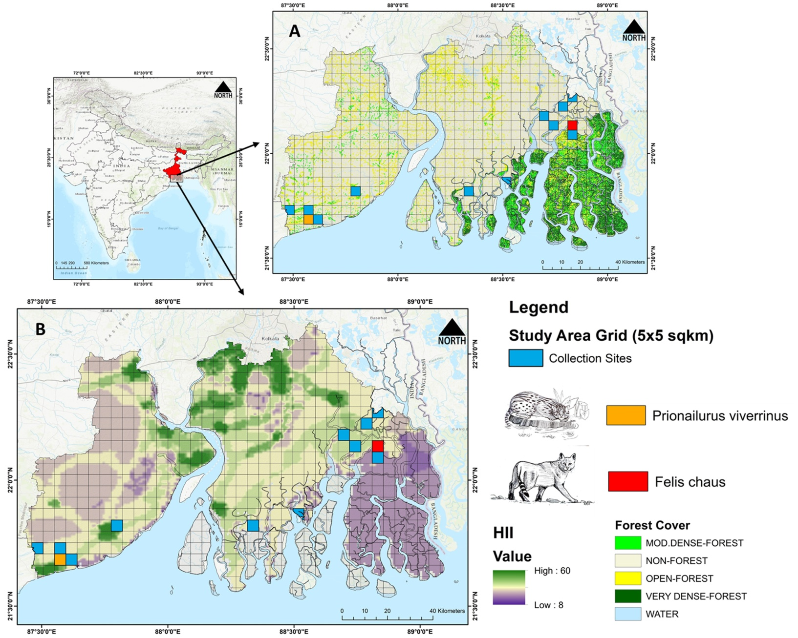

Figure 1: The map illustrates the sampling area for the practicum study from the Gangetic estuary of Eastern India. The blue and orange grids represents the recent reported areas of HWC. While, the orange and red grid indicates the locations awareness camps executed as part of the study. Here, (A) - shows the land use and land cover (LULC) map of the Gangetic estuary, and (B) - displays the anthropogenic areas using the Human Influence Index (HII). Data was collected from universal GIS data in USGS platforms

Objective behind the Study:

The study was aimed at a) generating awareness and b) impart training towards conservation of these wild cat species in the counties studied. To this end workshops were held with the help of two local non profits having a long history of association in the study area. These are Howrah Jela Joutha Paribesh Mancha (HJJPM) / The United People for Nature Foundation from Howrah and Society for Heritage and Ecology Research (SHER) around the SBR in South 24 Parganas. These nonprofits have been working for a long time in the locality towards capacity development for local communities through building of school, providing means of sustainable coexistence with local wildlife through alternative sources of income as well as acting as first responders for HWC incidents.

Target audience and awareness sessions:

The objective of awareness building was aimed primarily at two sections of the local populace. The first section, the student community, is comprised mostly of young people having a basic educational background including but not limited to college student and young professionals. This community usually comprises the backbone of the volunteer groups and wildlife responders of the area. I conducted workshops with them, engaging and training them in activities related to better scientific ways of documentation of local fauna. In turn they interacted with me sharing their experience of HWC cases and how they best mitigated those. It gave me an insight into the experiences that locals had to deal with in terms of HWC. In Howrah where the awareness about wildlife and their role in the surrounding ecosystem is highest thanks to the conservation activities of HJJPM, my sessions were more interactive and included practical training with handling of scientific devices like GPS and camera traps. The two sessions here were very informative for me as an outsider learning about first hand encounters and perception of community towards these predators. The hands on training session with the conflict responders could not have been completed without the help from HJJPM and it exposed the community to techniques for better monitoring and tracking of HWC cases. Fig 2 shows activities from this workshop.

I also conducted an awareness session with the zoology department of a local community college of East Midnapore county, Ramnagar College, discussing scientific survey techniques behind monitoring of felid carnivores (Fig 3). Table 1 shows a timeline of the workshops and detail of the participants held during the duration of the practicum. East Midnapore is a county where natural waterbodies are being utilized for aquafarming purposes and a lot of land is being utilized for developing artificial waterbodies to support more aquafarming ventures. The student community here apart from having a fundamental training of zoology and ideas behind species and their role in an ecosystem, also came from families within the local aquafarming community. This gave me an opportunity to interact with this community towards the future of these cats and their ecosystem.

|  |  |  |
| --- | --- | --- |
| Workshop Date | Workshop Venue | Number of Participants |
| 02/26/2024 | Pakhiralaya village, West Bengal | 15 |
| .5/10/2024 | Amta Block, Howrah County, West Bengal | 20 |
| 05/15/2024 | Ramnagar community College, East Midnapore county | 20 |
| 07/15/2024 | Panchla Block, Howrah County, West Bengal | 15 |

Table 1: List of workshops held during the practicum period

|  |
| --- |
|  |

Figure 2: Glimpses from workshop session with HJJPM workshop and awareness session.

|  |
| --- |
|  |

Figure 3: Glimpses from workshop session with community college in East Midnapore county.

With SHER in the South 24 Parganas district, with help of their local network of wildlife rescuers I held a session with local small, independent media houses which often comprise of independent journalists working off YouTube channels, reporting cases of HWC and making small environmental stories, spreading awareness among the locals about their local wildlife. This is a unique community who often at great personal risk spread awareness through local communities where access to mainstream media is often scarce. This session was held in the buffer areas of SBR, in a small village called Pakhirala (22.139367, 88.841671°). The SBR declared a UNESCO World Heritage site, became a Ramsar Site in 2019 increasing its importance as vital wetland areas (rsis.ramsar.org). The population here is impoverished, depending heavily on natural resources from the forests (Ghosh et al. 2015). The buffer zone covering an area of 5,367 sq km is densely settled with the mono-cropped agricultural community (Ghosh et al. 2015). Apart from being home of the flagship Sundarban tiger the area also acts as safe refuge to a different fauna of mammals and birds including the fishing cat. Nearly half of the total SBR is uninhabited with the inhabitants of this landscape having a deep-rooted culture of co-existence with the tiger making their stance towards other animals unique (Jalais 2010). Interacting with the volunteer community along with the independent journalists from the area, I was able to discuss the benefits of ecosystem and the role of the wild cat species apart from the tiger that inhabit their landscape and are responsible for sustenance of the unique ecosystem of SBR. This session gave me insight into the daily conflict instances from SBR and the people facing them and the ways in which they cope with these wildlife. To my surprise I found that people here revere the fishing cat just like the tiger and in spite of the losses that these cats cause as hunting of poultry animals.

|  |
| --- |
|  |

Figure 4: Interactive session with wildlife rescuers and independent journalists at SHER facility in SDB

Outcomes and Challenges faced:

I found the organizational part for the workshops to be quite challenging. It was a learning experience for me to coordinate with the volunteer groups towards identifying participants, get an idea of the local logistics required for arranging the event. The first times are always challenging, given the fact that I was mostly having an urban lifestyle, being raised in the Kolkata metropolis. The support from HJJPM was invaluable in this regard, helping in arranging for local logistics like venues for workshops and possible locations for conducting hands on practical training sessions which required identifying trails with possible presence of wild felids. This activity helped me in developing myself as an independent researcher providing exposure with the local nonprofit groups in the area towards a successful future as a community based conservationist. Another outcome from these sessions was setting up a group of first responders connected through channels like WhatsApp, who help in keeping in touch with researchers about HWC incidents round the year.

Findings and conclusion:

These workshop and awareness sessions gave me the opportunity to interact with the local populace over an extensive area of people from outside protected areas and explain to them the role of predatory species in any ecosystem and how they are beneficial to the community in ways that are not always obvious. The small cats and other similar mesocarnivores, comprising animals between 10-15 kgs in bodyweight, prey on a variety of smaller animals that are typically considered to be pests by agrarian communities. Most harmful among these pests are mice, rats and snakes. The diet-based study that I have been conducting in this landscape as part of my doctoral thesis has shown insight into the spectrum of prey base for these mesocarnivores which include apart from rats and snakes also various insects and insect species, which may otherwise cause harm to the farming community. Through the workshop sessions I also came to know that there is a seasonality in the activity of these predators. Specifically, their predation on poultry and farmed fish increases during the monsoon season.

Through my workshops and awareness camps, I also got a chance to meet senior level forest rangers, namely the field director/ chief ranger of SBR, who upon hearing about my communication with residents around his national park invited me to meet him and discuss my research and gave me his insight about the issues of HWC that he has been facing as a forest ranger. Surprisingly, these workshop sessions also had been featured in the local newsprint, being covered in detail by one particular prominent print media house Anandabazar Patrika (<https://www.anandabazar.com/education-career>). Through the media coverage, the workshop participants feel appreciated, which helps in the motivation of these volunteers towards protecting the natural life around them.

|  |
| --- |
| B  A |

Figure 5A: Session with SBR field director Mr Rajendra Jakker (left) explaining activities and HWC ideas. 5B: Coverage of workshop session held in Howrah by Anandabazar Patrika a prominent Kolkata/ eastern India based print media house.

Bibliography:

1. Mukherjee, S, Appel, A., Duckworth, J.W., Sanderson, J., Dahal, S., Willcox, D.H.A., Herranz Muñoz, V., Malla, G., Ratnayaka, A., Kantimahanti, M., Thudugala, A., Thaung, R. & Rahman, H. 2016. *Prionailurus viverrinus*. *The IUCN Red List of Threatened Species* 2016: e.T18150A50662615
2. Chakraborty, Samrat, et al. "Camera-trap records of fishing cat (Prionailurus viverrinus) from East Medinipur (West Bengal, India), and notes on threats to this population." *Écoscience* (2020): 1-8
3. Chakraborty, Samrat, et al. "State Representative Beaten to Death: A Decade Long Conflict Scenario of Fishing Cats (Prionailurus viverrinus) from Southern West Bengal, India." *Proceedings of the Zoological Society*. Springer India, 2022
4. Das, S. K., et al. "First estimates of fishing cat abundance and density in Lothian Wildlife Sanctuary, Sundarbans, India." *Cat News* 66 (2017): 25-27.
5. Jalais, Annu. *Forest of tigers: people, politics and environment in the Sundarbans*. Routledge, 2014
6. Ghosh, Priyanka. "Conservation and conflicts in the Sundarban biosphere reserve, India." *Geographical Review* 105.4 (2015): 429-440.