TCD Practitioner Grant Report Template

Please submit your report in a PDF format to tcd@latam.ufl.edu

General Info:
Project Title: Workshop: Can graduate students ground the helicopters? Practical considerations for safe, robust, and locally responsive research.
Name: Claudia J Garnica-Díaz (co-organized with Dr. Karen A. Kainer)
Degree: Ph.D. student
Department: Biology
Location of Research (City or Province/State or Protected Area/Reserve; Country): Coimbatore, India. PW-5 Workshop on the Association for Tropical Biology and Conservation (ATBC) 59th Annual Meeting.
Dates of Research: July 2nd – 6th.

Summary of Activities:
Please organize your 2 - 3 pages report following the specific topics and in the same order as below:

- Objectives
1. Discuss ways to acknowledge and integrate research status as an outsider.
2. Explore strategies to facilitate personal safety.
3. Illuminate ways to exchange knowledge, show appreciation, and potentially generate local benefits, while recognizing significant limitations.
4. Provide additional information/literature to deepen understanding of this topic.

- Brief description of the study area
Increasingly, tropical biologists and other scientists are called upon to address the inequities of “Helicopter Science” - when researchers from higher income or more privileged settings drop into resource-poor settings to gather data with limited to no involvement or acknowledgment of contributions by local partners and/or communities. The growing prevalence of topical literature and ready embrace by scientific societies to address diversity, equity, and inclusion speaks to the widespread desire to wholly address this relevant challenge. Thus, discussions regarding how to step away from approaches perceived as helicopter science are needed to balance science, conservation, and society.
- Summarized methods
The workshop focused on the roles and interests of graduate students in addressing the highly critical concept of Helicopter or Parachute Science. The premise is that graduate students are keenly interested in doing science that is equitable and fair yet also are very concerned with generating solid research that advances their career goals. We built on a previous workshop led by the graduate student representatives of the UF group on Challenging helicopter science group during Fall 2022. We created a space where these dual challenges of rigorous science and local relevance and benefits can be openly discussed, uncovering lessons learned by veteran graduate students, discussing practical alternative approaches to Helicopter Science, and generating a sense of common purpose with possible paths forward.

We carried out the workshop in four stages:

1) A brief opener and welcome, where the concept of helicopter or parachute science was briefly introduced. Additionally, we socialized the initiative of the “UF working group on challenging Helicopter Science” and shared scientific papers that will contribute to the participants in case they want to bring the discussion back to their institutions.

2) The participants were divided into two groups: one with veterans (those who carried out fieldwork and are reflecting on their experience), and one less experienced (those planning to do fieldwork) attendees. This allowed a more intimate discussion of concerns and questions related to the first three objectives, focused on four questions:
- How do I choose/approach a research/practicum partnership?
- How do you perceive the safety and self-care (e.g.: women, other bodies, and existences usually less respected) while doing fieldwork?
- What strategies do you use to follow cultural norms/appropriateness?
- What is your approach to being integrative and appreciative during international fieldwork?

3) Through a plenary session, both groups got together and shared their discussions in terms of the four main questions, while veteran students responded to less experienced students' concerns.

4) Wrap up and closure.

- Main results / outcomes (include figures if helpful).

- Choosing and approaching a partnership.
In India, partnering with the forestry department can simplify the challenging permit process, while field stations can be enhanced through collaborations with local guides and resources. To address language diversity, especially given India's numerous dialects, it's advisable to team up with local translators. Additionally, finding common ground with local communities, such as aligning research objectives with their interests, fosters acceptance. Recognizing the local significance of the study and consistently offering authorship to communities is crucial, allowing them to decide their level of involvement. Flexibility in this regard is essential, as seen in cases where local communities in the Philippines embraced publication inclusion for advocacy, while others preferred detachment due to resource access and reputation concerns. When establishing partnerships, consider integrating various levels of acknowledgment for a more effective collaboration.

- Safety and self-care during fieldwork.
When conducting your research, be mindful of sensitive interview questions. Keep in mind that safety rules at your institution may not match local standards, so adjust as needed. Try not to go by yourself to the field, as having a companion can boost safety perceptions, even if funds are tight. Steer clear of political debates or discussions. When it comes to dressing, consider local customs; blending in might not always be the best choice, as one student's experience in Madagascar, as he was taken as affiliated with the military as a covered agent. Be open and transparent about your research goals and results to avoid conflicts. Maintain transparency in your research process, ensure you have the necessary medications and permits, and aim to build positive relationships with collaborators, either by building on previous interactions or starting on the right foot.

- Following cultural norms/appropriateness.
In your research endeavours, it's essential to incorporate both ecological considerations and an appreciation for the community's identity. When sharing meals with locals and field assistants, adapt your food habits to signify a collaborative spirit, where everyone works cohesively toward shared objectives. Always maintain a holistic approach, ensuring that your work considers the broader context. Cultural awareness plays a pivotal role, encompassing clothing choices, respecting established schedules for various activities, and recognizing the dynamics between different genders. Promote equality in all your interactions and show respect for individuals' status within the community. Avoid episodic data collection; instead, aim to return and engage with the community to share and socialize your research results, fostering a lasting and meaningful connection.

- Being integrative and appreciative.
It's crucial to factor in the interests and needs of your local collaborators and the community. Building a strong foundation for collaboration involves effective communication, which could mean conversing in the local language or acquiring basic conversational skills. Maintaining workplace integrity is paramount throughout your interactions. Thus, consider leveraging your collective efforts to benefit the community's well-being by tapping into political influence, collaborating with the media, and utilizing social media platforms once the community/collaborators express interest in it. Always show appreciation and respect for your collaborators and field assistants by giving them the opportunity to be part of publications/ research outcomes and acknowledge them by name if the interest is expressed in doing so. Furthermore, fostering capacity building within the community should be a priority. An illustrative example comes from a student's experience in South America, where she provided training on sample processing and established laboratory protocols with local collaborators, thereby enabling more students to participate in valuable research efforts and continue the project after the field campaign ends.

- Challenges / changes to original proposal.
We did not have any need to change the original proposal.

- Photos* (can distribute in other sections of report if desired; provide captions)
*Reports will be posted to the TCD website, so only include photos where permission was granted by individuals photographed.

(a)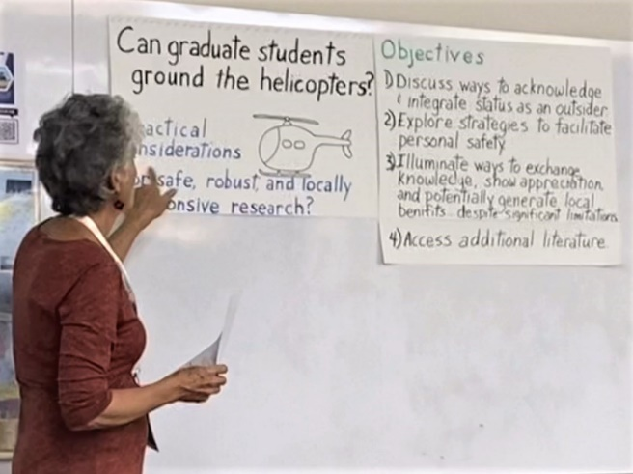 (b)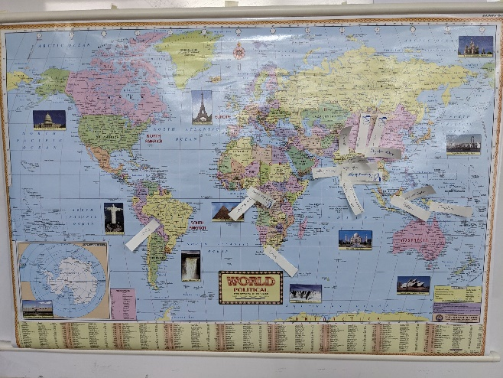
(c)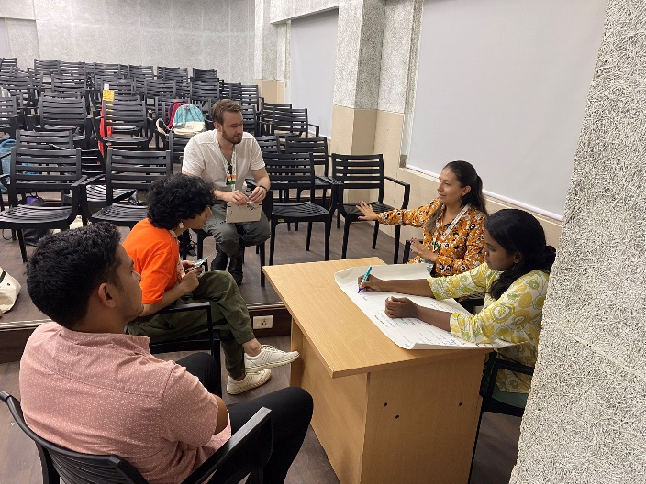 (d)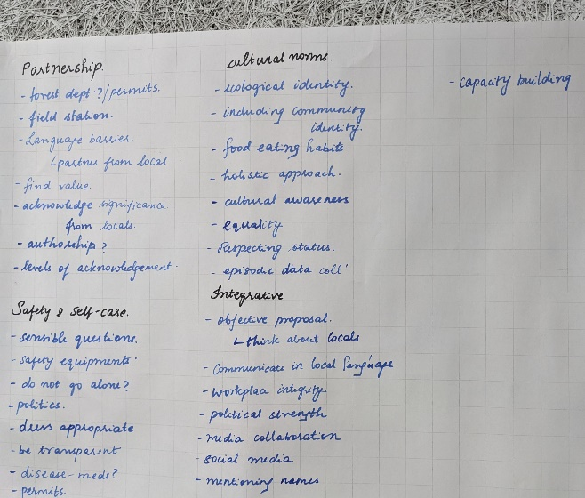
Fig 1. Workshop: “Can graduate students ground the helicopters? Practical considerations for safe, robust, and locally responsive research”. (a) Collaborating UF faculty, Karen A. Kainer introduces the workshop. (b) Map documenting where participants are from and where they work. (c) Claudia Garnica facilitates a small group discussion with participants who expressed less experience with fieldwork. (d) List of considerations for more equitable, robust, safe, and locally responsive research, from the less experienced participants.

